Sunday | Monday | Tuesday | Wednesday | Thursday | Friday | Saturday
      CARE CENTER | 1  9:30 What Job is it 2W  10:30 Exercise KH  11:15 UNO KH  12:00 Who Am I 1E-DR  2:00 IN2L Word Game KH  3:00 Dis: Party Lines 2W  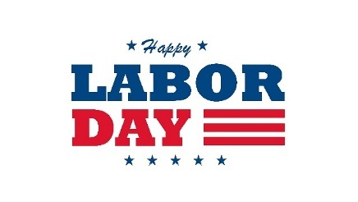 | 2  9:30 Exercise KH  9:30 Move to Music 2W  10:15 Short Stories 2W  10:15 Word Games KH  11:00 Resident Council KH  11:00 Finish That Line 2W  11:00 Visits 1E  12:00 Trivia 1E-DR  12:15 Trivia 2E-ER  2:00 Happy Hour w/ Joe Kadlec 1WP  3:30 Football Game KH  3:30 Crafts 2W  4:15 Visits 1W  4:15 IN2L Game 2W  5:00 Trivia 1W-DR  6:00 Short Stories 2W | 3  9:30 Exercise KH  9:30 Move to Music 2W  10:15 Sensory Room 2W  10:15 Leisure Cart 1E  10:30 sing w/Joan KH  11:00 Trivia 2W  11:15 Buncco Dice 2E  12:00 Trivia 1E-DR  12:15 Trivia 2E-DR  2:00 Bingo KH  2:00 Baking 2W  3:30 Coffee & Chat 2W  3:30 Bocce Ball 1WP  4:15 Visits 1W  4:30 Visits 2W  5:00 Leisure Cart 1W  6:00 Jokes 2W | 4 9:30 Balloon Volley 2W  9:30 Exercise KH  10:15 Reminisce 2W  10:15 Jeopardy KH  11:00 Library Outreach KH  11:00What’s That Sound 2W  12:00 Trivia 1E-DR  12:15 Trivia 2E-DR  2:00 Kings corner 2E  2:00 Cards w/ Friends KH  2:00 Bingo 2W  3:00 IN2L Game 2E  3:30 Adult Coloring 2W  3:30 Star of the Month KH  4:00 Visits 1E  4:15 Visits 1W  4:15 Visits 2W  5:00 Who am I 1W  6:00 Happy Hour 2W | 5  9:00 Visits 2E  9:30 Move to Music 2W  10:00 devotional Hour w/  St Francis Borgia CHL  10:15 Spelling Bee 2W  11:00 Large Dice 2W  11:15 Exercise KH  11:15 Visits 2E  12:00 Trivia 1E-DR  12:15 Trivia 2E-DR  2:00 Bingo KH  2:00 Paint by Number 2W  3:30 Yahtzee 2W  3:30 Ladder ball KH  4:30 IN2L Game 2W  5:00 Visits 1W  6:00 Hand Massage 2W | 6  9:30 Christ Alone  Worship ch 956  9:30 Sing Along 2W  11:00 Farkle KH  3:30 Movie: Hairspray  ch 956  3:30 Visits/Mail  
7 Activity Packets  Cards, Games and Puzzles available in Lounges and Kasten Hall  7 & 9 Sunday Mass Ch 24  9:00 Communion  visits by St. Francis  Borgia Parish  3:25 Packers Vs Detroit  CBS  6:00 Movie 2W   | 8 9:30 Move to Music 2W  9:30 Make a chia Pet KH  10:15 Sensory 2W  10:15 Exercise 2E  11:00 Trivia 2W  11:15 Movement w/  A Concept KH  12:00 Trivia 1E-DR  12:15 Trivia 2E-DR  1:15 Music:Joan&Margie 2W  2:00 Butterfly Craft 2W  2:00 Bingo KH  3:30 Family Feud 2W  3:30 Volleyball KH  4:15 Leisure Cart 1W  4:30 Visits 2W  5:00 Trivia 2W-DR  6:00 Who she was 2W | 9  8:30 Ladies Breakfast BWL  9:30 Balloon Volley 2W  10:15 Exercise KH  10:15 Name that Sound 2W  11:00 Travel Brief 2W  11:00 Skunk Dice KH  12:00 Trivia 1E-DR  12:15 Trivia 2E-DR  2:00 Picture this 2W  3:00 Catholic Mass CHL  3:00 Art 2W  4:15 Visits 1W  4:30 Word Game 2W  5:00 Visits 1W  6:00 Shake your # 2W | 10  9:30 Exercise KH  9:30 Move to Music 2W  10:15 Sensory Room 2W  10:15 Visits 1W  10:30 sing w/Joan KH  11:00 Name that Sound 2W  11:15 UNO 2E  12:00 Trivia 1E-DR  12:15 Trivia 2E-DR  2:00 Bingo KH  2:00 Baking 2W  3:30 Coffee & Chat 2W  3:30 Battleship KH  4:15 Visits 1W  4:30 Pretty Nails 2W  5:00 Social 1W  6:00 Mother Goose 2W | 11  11:15 Finish Lines 2W  11:15 Visits 1E & 2E  12:00 Trivia 1E-DR  12:00 Trivia 1W-DR  12:15 Trivia 2E-DR  2:00 Kings corner 2E  2:00 Cards w/ Friends KH  2:00 Bowling Dice 2W  3:00 Lutheran Worship w/  McClellian CHL  3:30 Balloon Volley 2W  3:30 Visits 1W  6:00 Music in the Courtyard w/ Garbage Pickers  7:15 Packers vs  Washington | 12 9:30 Balloon Volley 2W  9:30 Exercise KH  10:15 Roll it tic tac toe KH  10:15 Visits 2W  10:15 IN2L Game 2W  11:00 About Animals:  iguanas 2W  11:00 Bible Study CHL  12:00 trivia 1E-DR  12:15 Trivia 2E-DR  1:30 Sing w/Joan 2W  2:00 Big Screen Movie: The  Game Plan KH  3:00 Who AM I 2W  4:30 Visits 2W  4:15 Leisure Cart 2E  5:00 Visits 1W  6:00 Short Stories 2W | 13  9:30 Christ Alone  Worship ch 956  9:30 Who Am I 2W  11:00 UNO KH  3:30 Movie We Bought a Zoo ch 956  3:30 visits/mail  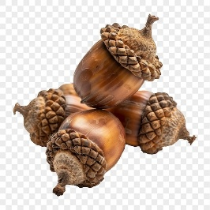
14  Activity Packets  Cards, Games and Puzzles available in Lounges and Kasten Hall  7 & 9 Sunday Mass Ch 24  9:00 Communion visits by  St. Joe’s Parish  6:00 Movie 2W   | 159:30 Move to Music 2W  9:30 Travelogue KH  10:15 Yahtzee 2W  10:15 Baking 2E  11:00 Match Game 2W  11:15 Movement w/  A Concept KH  12:00 Trivia 1E-DR  12:15 Trivia 2E-DR  1:15 Music:Joan&Margie 2W  1:30 Visits 2W  2:00 Bingo KH  3:00 Discussion 2W  3:30 Shuffle board KH  4:00 IN2L Game 2W  4:15 Visits 1W  4:30 Visits 1E  5:00 Trivia 1W-DR  5:00 Visits 2W  6:00 Match Game 2W | 16  9:30 Balloon Volley 2W  9:30 Exercise KH  10:15 Horseracing KH  10:15 Spa Day 2W  12:00 Trivia 1E-DR  12:15 Trivia 2E-DR  2:00 Happy Hour w/  Roger Boll 1WP  3:30 Lucky Dog 2W  3:30 Wheel of Fortune KH  4:15 Visits 2W  4:15 Visits/Leisure Cart 1W  5:00 Who am I 1W-DR  5:00 visits 2W  6:00 who am I 2W | 17  9:30 Exercise KH  9:30 Move to Music 2W  10:15 Name That Tune 2W  10:15 visits 2E  10:30 Sing with Joan KH  11:00 Chicken Soup 2W  11:15 Farkle Dice 2E  12:00 Trivia 1E-DR  12:15 Trivia 2E-DR  2:00 Bingo KH  2:00 Shut Box 2W  3:30 Yahtzee 2W  3:30 Bocce Ball 1WP  4:15 Visits 1W  5:00 Leisure Cart 1E  5:00 Visits 2W  6:00 Name that country Artist 2W | 18 9:30 Balloon Volley 2W  9:30 Spa Day KH  10:15 About Animals  Humming Birds 2W  11:15 Trivia 2W  12:00 Trivia 1E-DR  12:00 Special Lunch BWL  2:00 Cards with Friends KH  2:00 Crafts 2W  2:00 Kings Corner 2E  3:15 Exercise KH  3:15 Farkle 2W  3:30 Visits 2E  4:00 Wheel of Fortune KH  4:00 Who Am I 2W  4:15 Visits 1W  5:00 Social 1W  5:00 Visits 2W  6:00 Star of the Month 2W | 19  9:30 Exercise KH  9:30 Balloon Volley 2W  10:15 Dis: Generations KH  10:15 Sensory Room 2W  11:00 Rosary CHL  11:00 Trivia 2W  12:00 Trivia 1E-DR  12:15 Trivia 2E-DR  1:30 Sing w/Joan 2W  2:00 Travel Club:  Germany KH  2:45 Hand Massage 2W  3:30 Lucky Dog KH  3:30 Short Stories 2W  4:15 Visits 1W  4:15 Match Game 2W  5:00 Visits 2W | 20  9:30 Christ Alone  Worship ch 956  9:45 Sing Along 2W  11:00 Kings Corner KH  3:30 Movie: Sweet Home Alabama ch 956  3:30 Visits/Mail
Sunday | Monday | Tuesday | Wednesday | Thursday | Friday | Saturday
21  Activity Packets  Cards, Games and Puzzles available in Lounges and Kasten Hall  7 & 9 Sunday Mass Ch 24  9:00 Communion  visits by St. Francis  Borgia Parish  12:00 Packers @ Cleveland  Fox  6:00 Movie 2W | 22 9:30 Balloon Volley 2W  9:30 About: Greenbay  Packers KH  10:15 Short Stories 2W  10:15 Word Game KH  10:15 Lucky Dog Dice 2E  11:00 Exercise 2E  11:00 Finish Lines 2W  11:15 Movement w/  A Concept KH  12:00 Trivia 1E-DR  12:15 Trivia 2E-DR  1:15 Music:Joan&Margie 2W  2:00 Bingo KH  2:15 Crafts: Poppies 2W  3:30 Bowling KH  3:30 IN2L Game 2W  4:15 Visits 1W  4:30 Sensory Room 2W  5:00 Trivia 1W-DR  6:00 U B the Judge 2W | 23  9:30 Move to Music 2W  9:30 Exercise KH  10:00 LRC Dice Game KH  10:15 Leisure Cart 1E  10:15Jeopardy 2W  11:00 Battleship KH  11:15 Ball toss 2W  12:00 Trivia 1E-DR  12:15 Trivia 2E-DR  2:00 Scenic Drive  2:00 Yahtzee 2W  2:00 Bio: Milton Hershey KH  3:30 Picture this 2W  3:30 Bowling Dice KH  4:15 Visits 1W  5:00 Jokes 1W-DR  5:00 Visits 2W  6:00 Hand Massage 2W | 24  9:30 Exercise KH  9:30 Move to music 2W  10:15 Sing w/Joan KH  10:15 IN2L Game 2W  11:15 Crossword puzzle KH  11:15 Name that Sound 2W  12:00 Jokes 1E-DR  12:15 Trivia 2E-DR  2:00 UNO 2W  2:00 Bingo KH  3:00 Sensory Room 2W  3:15 Buncco KH  3:45 Who Am I 2W  4:15 Leisure Cart 1W  4:30 Visits 2E  6:00 Happy Hour w/ Sting Along Band KH | 25  9:30 Exercise KH  9:30 Move to music 2W  10:15 Bunco Dice KH  10:15Wheel of Fortune2W  11:00 Trivia 2W  12:00 Trivia 1E-DR  12:15 Trivia 2E-DR  2:00 Pretty visits 2W  2:00 Cards w/Friends KH  2:00 Men’s Group 1W  2:00 Kings Corner  w/Emma 2W  3:00 Lutheran Worship w/  Maschkee CHL  3:30 Senior Science KH  4:15 Leisure Cart 1W  4:15 Short Stories 2W  5:00 Trivia 1W  6:00 Discussion 2W | 26  9:30 Exercise KH  9:30 Balloon Volley 2W  10:15 History Club NFL KH  10:15 Sensory Room 2W  10:15 Visits 2E  11:00 Match Game 2W  11:30 Visits 1E  11:00 Bible Study CHL  12:00 Trivia 1E-DR  12:15 Trivia 2E-DR  2:00 Crafts 2W  2:00 Big Screen Movie KH  3:00 Lucky Dog 2W  4:00 Discussion 2W  4:15 Visits 1W  4:45 Visits 2W  5:00 You be the Judge1W-DR  6:00 About Johnny Apple  seed 2W | 27  9:30 Christ Alone  Worship ch 956  9:45 Faith Study 2W  11:00 LRC Dice KH  3:30 Movie: Click Ch 956  3:30 Visits/Mail
28  Activity Packets  Cards, Games and Puzzles available in Lounges and Kasten Hall  7 & 9 Sunday Mass Ch 24  9:00 Communion  visits by St. Joe’s Parish  6:00 Movie 2W  7:20 Packers @ Dallas NBC | 29 9:30 Move to Music 2W  9:30 Teachers Day KH  10:15 IN2L Game 2W  10:15 Exercise 2E  10:30 Visits 2E  11:00 Trivia 2W  11:00 Dis: I heard it through  the grapevine 2E  11:15 Movement w/  A Concept KH  12:00 jokes 1E-DR  12:15 Trivia 2E-DR  1:15 Music:Joan&Margie 2W  2:00 Baking 2W  2:00 Birthday Bingo KH  3:00 Coffee w/ Friends 2W  4:15 Visits 1W  4:00 Name that Object 2W  4:00 Hand Massage 2E  4:00 UNO KH  5:00 Trivia 1W  6:00 Short stories2W | 30  9:30 Exercise KH  9:30 Move to Music 2W  10:15 About Oktoberfest KH  10:15 Short Stories 2W  11:00 Finish Phrases 2W  11:00 Crafts w/ Donna KH  12:00 Trivia 1E-DR  12:15 Trivia 2E-DR  2:00 Oktoberfest w/ John  Raymond KH  3:30 Trophy Bingo 2W  3:30 Kings Corner KH  4:15 Cards 2W  4:15 Leisure Cart 1W  4:30 Visits 2E  5:00 Visits 2W | 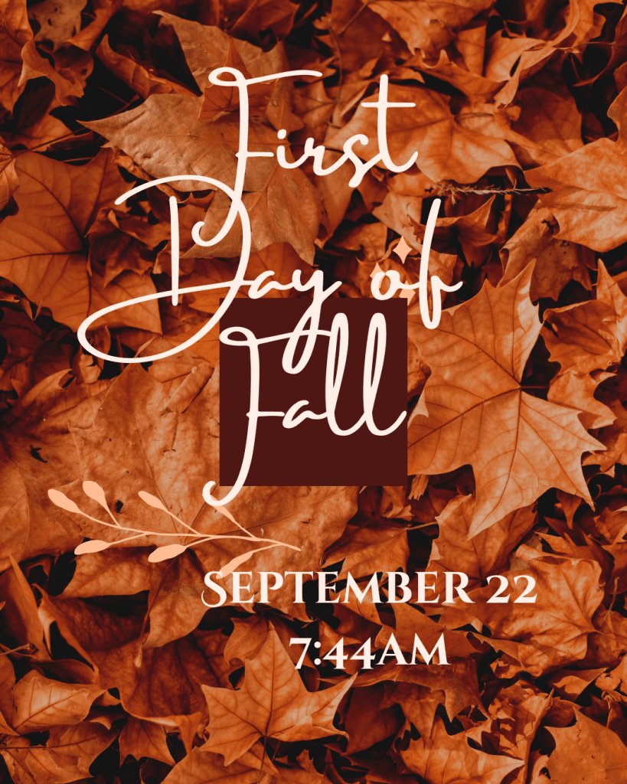   |  | 